Randal Mills
Prof. Jenifer Hart
HON 4250
12/13/2021
Urban Futures Final Project Reflection: Downtown Dexter Crosswalk
Since its foundation in 1824 by Samuel W. Dexter, the community known as Dexter, MI has gone from a relatively small countryside area, into an official large, community-oriented city. The downtown area has served as one of its oldest locals, with several of the buildings still retaining their original architectural designs from when they were first constructed over a century ago. This has been maintained even as the village was officially rebranded as a city which is due to, within the intervening decades, the growing population that has increased the residents up to "4,644". (SEMCOG)
Years ago, when I was still in my adolescence, my family moved to Dexter, and we became part of that growing community. Living within Dexter, we experienced many of its local traditions, businesses, politics, economic situations, and became acquainted with the public mentality shared among the residents. We remained there until I was 19 years of age, at which time my family and I moved out to Novi Michigan. Years later, as part of my Urban Mapping Project, I returned and began to conduct fieldwork, gathering data and seeing how much the city had changed since I had departed from its borders. As a former member of the community, I had a mental perception on what I might encounter and accumulate data-wise. I managed to uncover some interesting discrepancies in the downtown area's operational structure. Right where Main Street runs through the town center, a three-way road intersection is arranged so vehicles are able to traverse through the town. However, the crosswalks which allow community members and visitors to Dexter to access the north and south sections of the town are hindered by how the traffic circulation is conducted. To be specific, the two crosswalks linking the north and south sides of the town have crossing signals that never alter between the stop and walk signals. Instead, they only remain locked on the stop signal. The significance of this is due in part to pedestrians being forced to gamble on their lives and make their way to the other side of town they are intending to reach. Regardless of which side of the town pedestrians park their vehicles, in order for them to reach the other side they must endure the unchanging crosswalk signal.
Being on the ground and engaging with the individuals who were expressing their frustration towards this error in design allowed me to empathize, or in my case as a former resident of Dexter reemphasize, with their predicament. I started conducting research on dextermi.gov as to the origin of why this traffic arrangement was set in such a manner, and if anything was already being undertaken to correct it. Accessing the City Council reports, which are publicly available for anyone to access, revealed that this functional error in traffic control had already been brought forth to Dexter's governing body. However, instead of finding a forthcoming solution, I instead encountered a continuously delayed response. I went to the lasted report at the time of my research, dated November 8, 2021, which listed a set of tasks regarding multiple locations in Dexter that indicated pedestrian issues with multiple crosswalks. The very first task concerned the location, Main Street, I was researching, and was as follows:

“The existing signal located at this intersection does not currently provide for a protected pedestrian phase, i.e. a Leading Pedestrian Interval (LPI). An LPI gives pedestrians a leading WALK indication of approximately 4-7 seconds prior to the adjacent street getting the vehicle green. This allows pedestrians to have a head start into safely crossing the road.
If the City wishes to have a measurable result on the impacts at this intersection, OHM could use Synchro to model the area treating it as a special form of an all-red. Recent or new turning movement counts (TMC) at the intersection would be necessary. The before and after results of the intersection would be compared.” (City Council, Nov. 8, 2021. p 210)

Initially, I was under the impression that this meant it was only a matter of time before the goal was met and concerns were sated. In fact, this very solution was discussed at a later date when I consulted my student peers who suggested a similar solution. The idea of having the vehicle traffic lights entering a brief segment where they were all red would not only allow pedestrians to cross safely, but would also greatly reduce the potential for vehicular manslaughter. However, further research indicated the slow level of progress conducted by the City Council on this and other matters suggested this would not be the case. I uncovered plans, highlighted in multiple City Council reports, that was intended to offer an alternative solution to the problem, but has been put on hold since September 29th, 2020. Classified as the “Pedestrian Safety Project”, this was intended to be both a video production was to display “proper crossing techniques” and a newsletter recruitment for crossing guards. (City Council, Sep. 14, 2020. p 27) However, as of the latest report, dated December 13, 2021, no progress on either of these objectives has been achieved nor is any, seemingly, forthcoming. In fact, there is a clear sign of negligence right in the December report which clearly states that filming will be postponed until “the spring of 2021” (City Council, Dec 13, 2020. p 64) even though this report was issued a full season later. There is also a line that reveals they have posted the recruitment add for crossing guards, but no statement if any potential candidates have come forward. It is also notable that in a report that was released the same month as the initial proposal back in 2020, a complaint was issued regarding the crosswalk by a resident of Dexter who stated, “Can we put up several of the “stop for pedestrian in crosswalk signs on Main and Central (in the middle and on the side bike lane lines) to calm traffic?” (City Council, Sep. 28, 2020. p 23) Furthermore, in the December report, another complaint about the same location was being filed, “Traffic signal at Main St. and Baker Rd. – a request from a resident to give additional consideration to pedestrians at the Main St. and Baker Rd. intersection, including looking at a leading pedestrian interval.” (City Council, Dec. 13, 2021. p 99)
This demonstrates a consistency in governmental neglect of the citizens who rely on proper traffic circulation to conduct standard commerce throughout the town. The potential death of a civilian has not served as sufficient motivation for Dexter’s City Council to double their efforts or follow through on what they have already proposed. I searched to find out where this all began, and discovered it on a easy to miss page in the newsletter on dextermi.gov, “Starting after morning rush hour on Thursday, August 27, 2020 work will take place to upgrade the traffic signals at the intersection of Main and Baker. The new signals will be set to run new timings, and will include a flashing yellow arrow to allow for left turns from Main onto Baker (similar to the light at Broad and Main). There will be a three-way stop at this intersection as this work takes place.” (Traffic Signal Upgrade) This discovery revealed the very reason as to why this issue arose in the first place. By putting more priority on the speed in which vehicle enter and leave the downtown area, the greater the risk was put on pedestrians who were crossing. With this realization, I zeroed in on the slogan for my visual: Change the Signal!
The design itself is a simplified version of downtown Dexter central hub and the freeway traffic cross located on Main Street. Much of the focus was placed on the colors maroon, gold, and white, which are representative of Dexter and its culture, being utilized in sporting events, worn by the sport teams, adorned in every school, featured in the parades, and synonymous with dexter days; and annual celebration hosted by Dexter in the downtown area. My design has the texts and buildings feature these colors to form a connection with my target audience. The crosswalk signals, which are arguably the main feature within the design, are placed exactly where the cross signals are located in the downtown Dexter area. Likewise, and to signify their error as an essential function in the area, the particular signals that the pedestrians have been expressing concerns over are exemplified by the stop hand. To express the juxtaposition of this predicament, the third crosswalk is represented by walk signals. This is to highlight that this singular crosswalk is the only one functioning at standard operating procedure and, as a result, is the only one of the three crosswalks that is safe to use.
Harkening back to the political aspect that is associated with this project, the figures representing the City Council are standing in the middle of the safe crosswalk, showcasing that they are unburdened with the situation in direct opposition of the other pedestrians. Said other pedestrians are featured at the two unsafe crosswalks, both strategically designed to invoke the proper emotional reaction to my target audience and demonstrate the urgency in which the signals need to be changed. The figure on the left crosswalk exemplifies the state of experience in which pedestrians must cross. The designs of the figures are similar to that of the standard walk-signal icon, in which all the figures in the design are patterned off of; but featured in different physical positions to represent their stance in the situation. Unlike the City Council members on the top, however, the figure on the left is running for his life attempting to get all the way of an oncoming car. This is representative of what actually occurs in the downtown area as a result of the cross signal remaining unchanged. The pedestrian on the right is that of a mother and her baby, and their presence is intended to drive home the innocent lives that can be taken if the signals are not changed soon. The final figure, located at the bottom of the design, is holding a bag of money and is, with purpose, placed directly in a safe location, on the sidewalk, and out of the oncoming path of the vehicles. Like the central City Council figure above, the bottom is dressed up nicely representing the social power gap that exists between the standard resident and a member of the governmental authority that wields the decision making on matters such as this. This visual design is intended to spur more residents of Dexter, MI to let those with the authority to ‘Change the Signal’ know not to take the matter for granted; focusing the message on what the City Council won’t do of their own initiative until it is, potentially, too late. That there it’s possible to prevent disastrous ramifications such as public unrest, lawsuits, and loss of life through vehicular manslaughter.

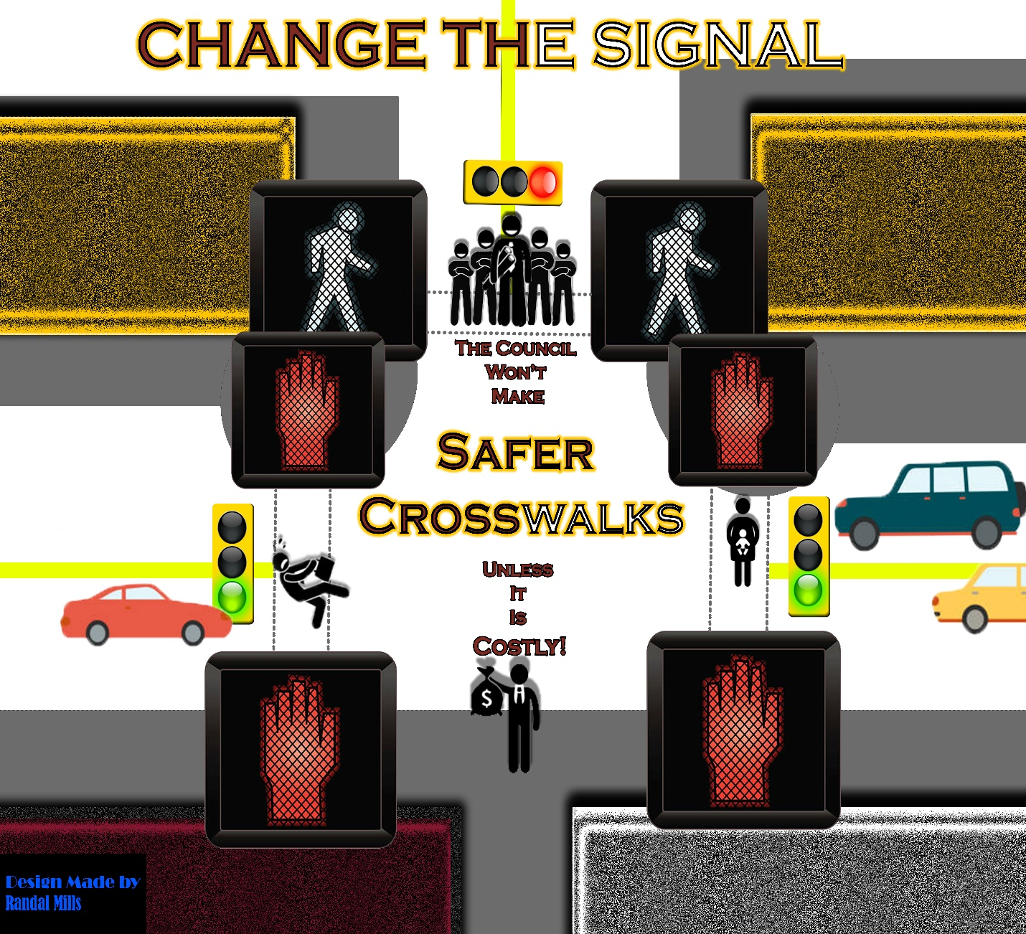

Works Cited
“Traffic Signal Upgrade”. The City of Dexter Michigan, https://www.dextermi.gov/news_detail_T39_R122.php.
Mayor Keough, et al. “The City of Dexter Regular City Council Meeting”. Dexter MI, PDF, https://files.dextermi.gov/City_Council/2020/Packets/2020-09-28-CC-P.pdf, September 14, 2020. p 27.
et al. “The City of Dexter Regular City Council Meeting”. Dexter MI, PDF, https://files.dextermi.gov/City_Council/2020/Packets/2020-09-28-CC-P.pdf, September 28, 2020. p 23.
Arab, Sanam. et al. “The City of Dexter Regular City Council Meeting”. Dexter MI, PDF, https://files.dextermi.gov/City_Council/2021/Packets/2021-11-22-CC-P.pdf, November 8, 2021. p 210-211.
Arab, Sanam. et al. “The City of Dexter Regular City Council Meeting”. Dexter MI, PDF, https://files.dextermi.gov/City_Council/2021/Packets/2021-12-13-CC-P.pdf, December 13, 2021. p 64, 99.
“Community Explorer”. SEMCOG, https://maps.semcog.org/CommunityExplorer/?community=4030&shortcut=Total_Population.

